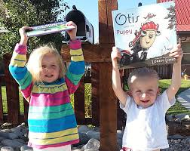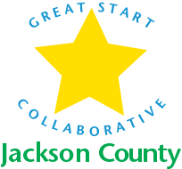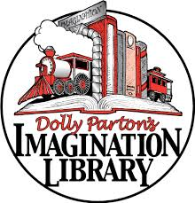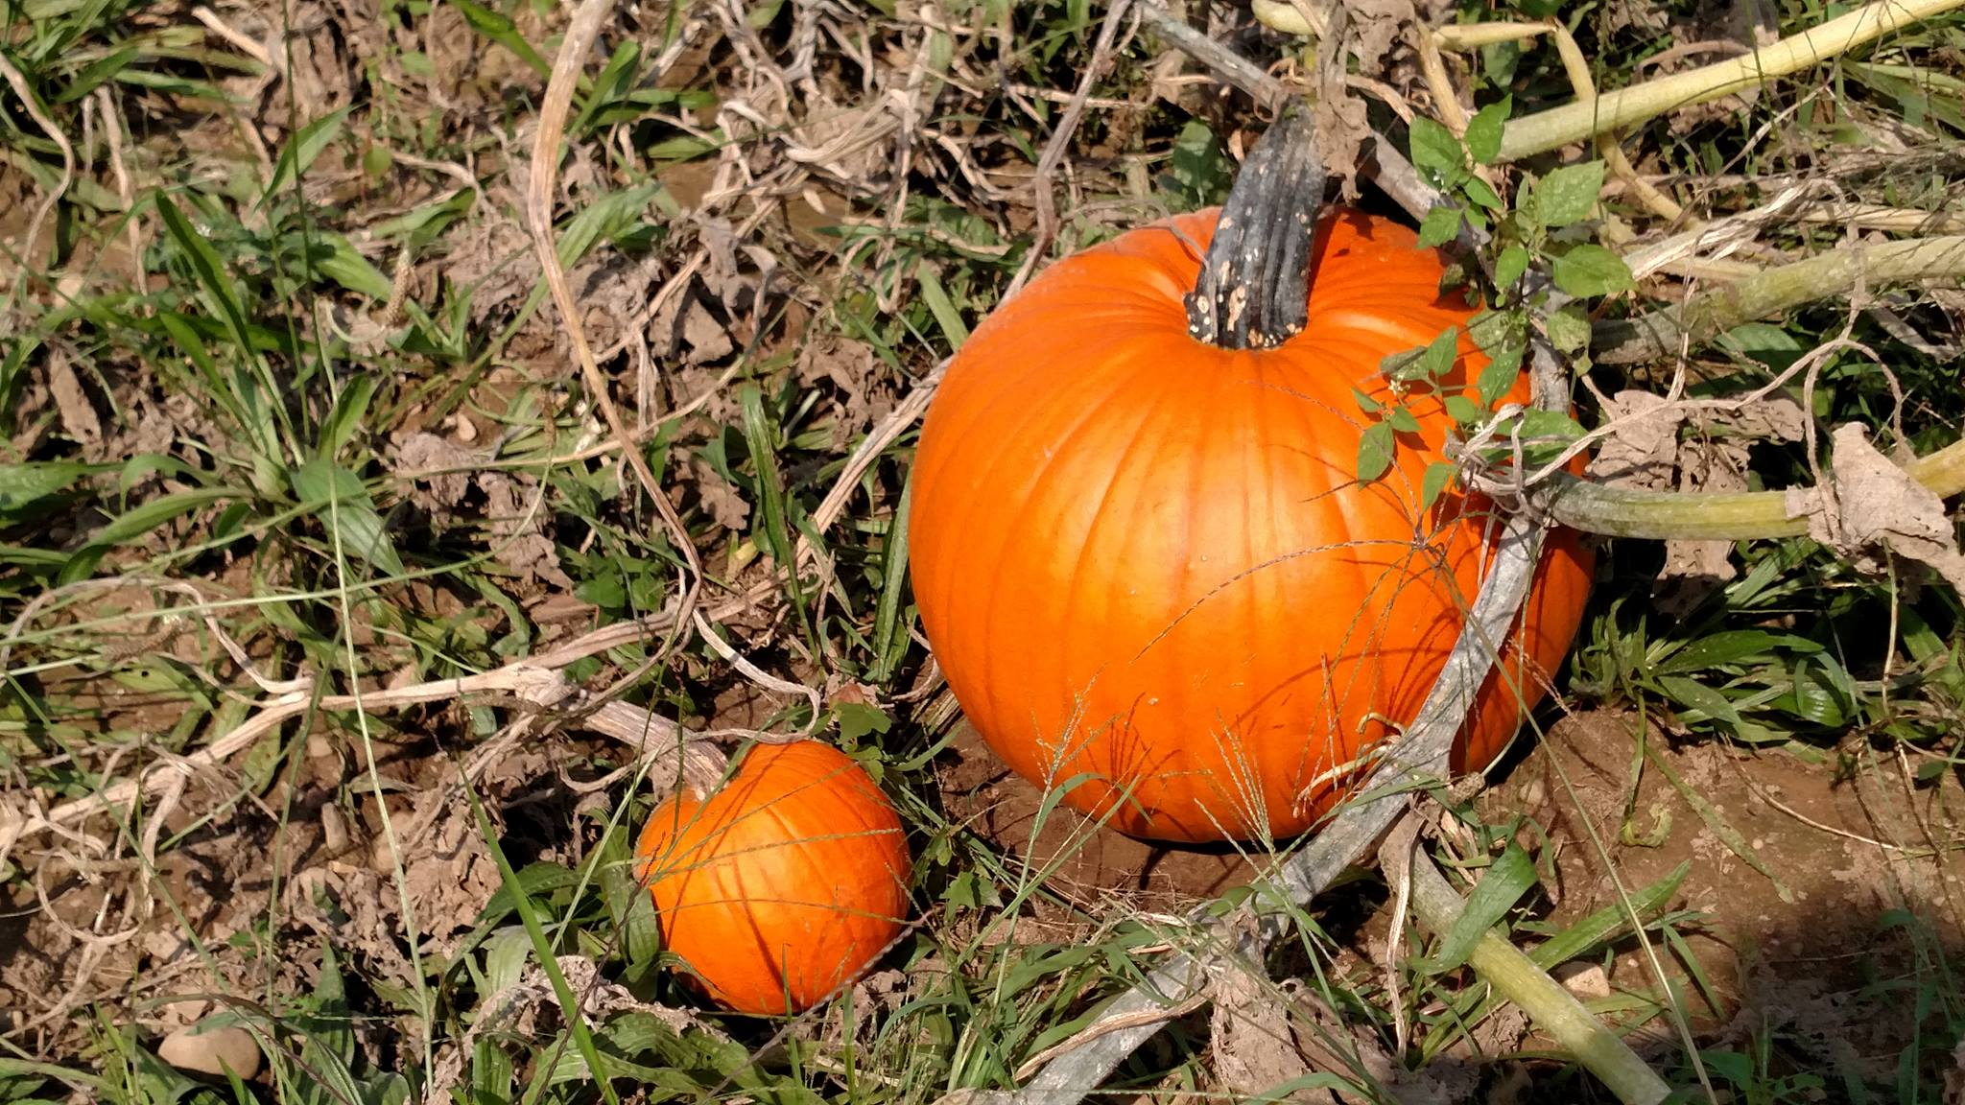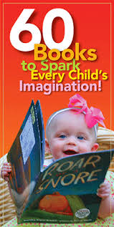

Red Egg Farm and the Great Start Collaborative are partnering together to raise money to support the

**Jackson County Imagination Library Program**.

**WHEN: Sunday, October 23rd : anytime 10am to 7pm**

**WHERE: Red Egg Farm, 9123 Spring Arbor Road, Spring Arbor**

**COST: $2.00 per person for Corn Maze and FREE book for**

**kids while they last!!**

Red Egg Farm has pumpkins, wagon rides, cider and donuts, petting zoo and more! Bring your family to enjoy the fun and support this important reading program for children birth to 5.

***www.greatstartjackson.org***



C

**Corn Maze “fun”draiser for Imagination Library**